******Room 105’s Supply List**



[This Photo](https://www.freepngimg.com/png/48550-chair-download-free-hq-image) by Unknown Author is licensed under [CC BY-NC](https://creativecommons.org/licenses/by-nc/3.0/)

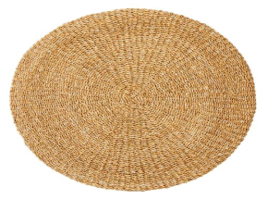

[This Photo](https://freepngimg.com/png/49148-rug-png-image-high-quality) by Unknown Author is licensed under [CC BY-NC](https://creativecommons.org/licenses/by-nc/3.0/)

**Please label all material with your name or initials.**

***Can’t wait to meet you ALL!***

**Thank you for purchasing these supplies. These supplies will last us all year and will help us to have a successful year.**

**4 boxes of 24 colors Crayola crayons**

**8 washable markers**

**24 sharpened pencils**

**2 large pink erasers**

**8 glue sticks**

**2 folders (plastic bottom pocket folders last longer)**

**1 green folder (for school and home communication)**

**1 blue folder (Writing Folder)**

**1 Mead Primary Journal K-2**

**Dry Erase White Board (8.5” x 11” is a good size)**

**6 thin black EXPO dry erase markers**

**1 plastic snap shut pencil box**

**1 package of 3x3 Post-It notes**

**1 pair of Fiskars scissors (blunt tip)**

**1 pair of headphones (place in a ziploc bag with name) No Ear Buds.**

**2-3 containers of Clorox wipes**

**3 boxes of tissues**

**1 gallon size ziploc bags (last names A-L)**

**1 quart size ziploc bags (last names M-Z)**